INTAPT 2024-25
Topic: Fold, Reflect, and Repeat: Teaching Procedural Skills and Debriefing through Origami
Date: February 26, 2025
Presenters: Akshay Verma, Disha Arora, Justin McNish, and Olivia Li
N = 8 / avg rating = 5.00
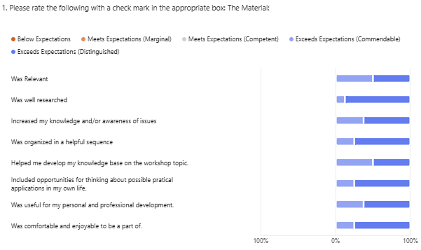
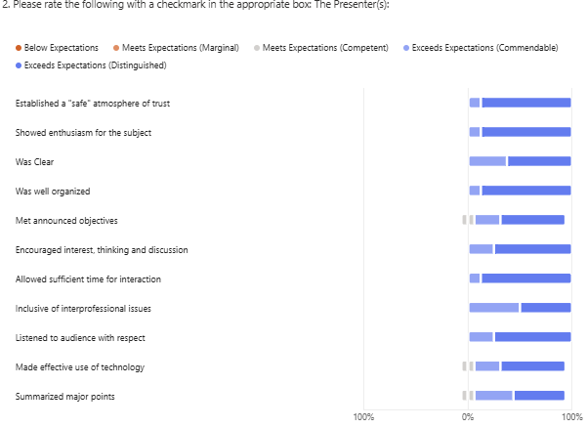

What I liked best:
Interactive nature
I loved the use of origami to help illustrate the different stages of learning
Really liked the origami activity as a major theme to teach the points. It kept us very engaged.
The use of the origami task and actually going through all the stages was a great example.
Experiential learning opportunity in such an exciting, engaging manner! Thank you :)

What I learned from this session:
Personal reflections of the Kolb cycle
The PEARL framework for debriefing
Learned a debriefing framework and how to apply Kolb’s learning theory for teaching procedural skills.
The kolbs experiential learning cycle in depth
Relevance of different stages of cycle - when feeling the need to move. Handouts for debrief helpful.
For an experiential-style learner, it might be good to consider observing others after acting first time yourself before directly seeing instraction to learn more effectively.

Suggestions for Change:
I think in the end it felt most like a session about kolbs and origami, I would encourage more reflection about bringing it back to real world examples and applications to *teaching* procedural skills in the clinical context, rather than just experiencing the stages as the learner. But overall a really great workshop.
- clarifying objectives along the way / circling back to them

